**Business Intelligence Guidebook**

**Templates**

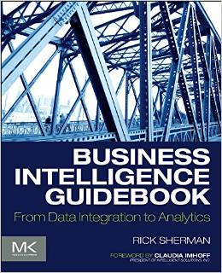

**Chapter 9:**

**BI Dimension Model Design Template**



[Company Name]

BI Dimension Logical Model Design Template

[Project Name]

Date: [Select Date]

Author(s):

Sponsor(s):

Table of Contents

BI Dimensional Logical Model Design 4

Data Stores 4

Data Subjects 4

Entities 5

Data Store Entity Model 6

Approvals 7

Appendix: Background Materials 8

Authors and contributors 8

|  |  |
| --- | --- |
|  | The content of the template is what is important rather than how is presented or formatted. If the project uses a data modeling tool then the contents of this document may be created and managed in that tool.  **Note: to delete any tip, such this one, just click the tip text and then press the spacebar.** |

# BI Dimensional Logical Model Design

|  |  |
| --- | --- |
|  | See Chapter 9 “Dimensional Modeling” of the BI Guidebook for a discussion on the purpose and design of a BI dimensional model. A logical dimensional model should be created for each data store within the BI data architecture. The physical model will be dependent on the technology used to implement a data store. |

## Data Stores

|  |  |
| --- | --- |
|  | List and describe the use of the proposed data stores to be used in the BI data architecture.  Note: The schema types include integration, distribution, staging and analytical. |

Table : BI Data Stores

|  |  |  |  |  |
| --- | --- | --- | --- | --- |
| Data Store | Schema Type | Description | Status | Person Responsible |
|  |  |  |  |  |
|  |  |  |  |  |
|  |  |  |  |  |
|  |  |  |  |  |
|  |  |  |  |  |
|  |  |  |  |  |

## Data Subjects

|  |  |
| --- | --- |
|  | List and describe the data subjects present in each of the data stores in the BI data architecture. |

Table 2: BI Data Stores

|  |  |  |
| --- | --- | --- |
| Data Store | Data Subject | Description |
|  |  |  |
|  |  |  |
|  |  |  |
|  |  |  |
|  |  |  |

## Entities

|  |  |
| --- | --- |
|  | It is easiest to think of these entities as tables, especially during the preliminary logical design. When physical models are created, these entities may be instantiated as views or virtual entities rather than tables.  Notes:   * Entity Types: Dimension, Fact, Bridge * Entity Subtypes: See Chapters 9 and 10 of the BI Guidebook for a description of each type of fact, dimension and bridge table. |

|  |  |
| --- | --- |
|  | List and describe the entities that will be created within each data subject and data stores in the BI data architecture. |

Table 2: BI Entities

|  |  |  |  |  |  |
| --- | --- | --- | --- | --- | --- |
| Data Store | Data Subject | Entity (Table) | Entity Type | Entity Subtype | Description |
|  |  |  |  |  |  |
|  |  |  |  |  |  |
|  |  |  |  |  |  |
|  |  |  |  |  |  |
|  |  |  |  |  |  |
|  |  |  |  |  |  |
|  |  |  |  |  |  |
|  |  |  |  |  |  |
|  |  |  |  |  |  |
|  |  |  |  |  |  |

## Data Store Entity Model

|  |  |
| --- | --- |
|  | For each data store provide a logical data model of the entities only. |

|  |  |
| --- | --- |
|  | For illustration purposes the diagrams in this template use a modified version of sample databases provided by Microsoft’s Adventure Works. These samples support learning BI concepts in conjunction with SQL Server and associated products, but from the logical modeling perspective are vendor agnostic.  You can examine the latest samples in CodePlex, TechNet or MSDN. |

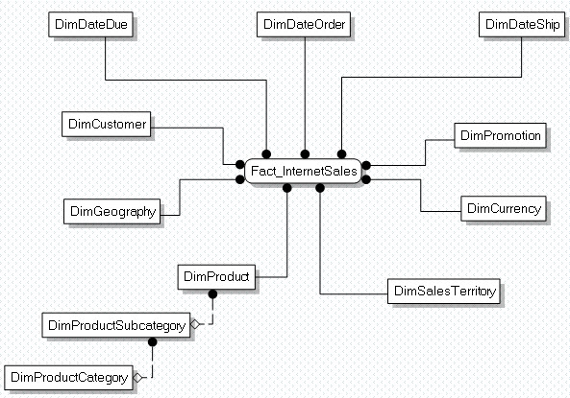

Figure : Example of a Data Store's Entity Logical Data Model

# Approvals

|  |  |
| --- | --- |
|  | It is a best practice to obtain sign-off approval of each project milestone. An organization’s policies and culture will dictate who the approvers will be, but typically the sponsors and key stakeholders are included. |

|  |  |  |
| --- | --- | --- |
| Title | Name | Approval  Date |
|  |  |  |
|  |  |  |
|  |  |  |
|  |  |  |
|  |  |  |

# Appendix: Background Materials

|  |  |
| --- | --- |
|  | This section includes all background or supporting materials for the BI Milestone Plan. These materials may include:   * The milestone plan assumptions such as resources, funding, etc. * A more detailed project plan if defined |

## Authors and contributors

|  |  |
| --- | --- |
|  | List all the people involved in obtaining and analyzing the requirements, along with the authors of this deliverable. |